SmartPlant 3D
Orthographic Drawings Setup Training

Overview
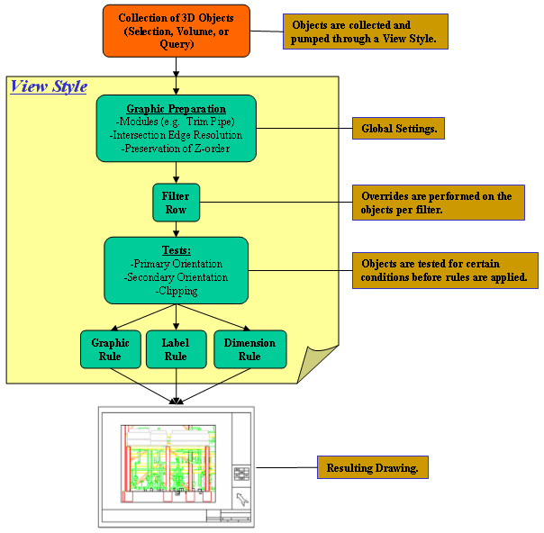

There are 2 key steps to the creation of an SP3D orthographic drawing template:
- Define the seed and border files
  - Create blank seed file with desired presets
  - Define graphic styles template
  - Create reference border template
  - Map title block attributes
- Define the view style rules for each type of drawing desired
  - Preparation rules
  - Graphic rules
  - Label rules
  - Dimension rules

Defining Seed and Border Files

The following instructions make use of the Intergraph training plant. They assume a metric drawing requirement of size A1. The files created will be used for plan and elevation drawings. User training in ortho drawing creation is a prerequisite.

Creating the Drawing Template

- Navigate to your plant’s templates folder at
\\yourSP3Dserver\ yourSymbolsShare\Drawings\Catalog\templates
- Copy empty.Sha to a backup name, i.e. copy of empty.Sha
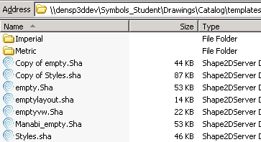
When a new ortho is created, empty.sha will be the file used as the seed for the new drawing so that you must configure it to match the desired look and feel for the project orthos
- Open your template in SmartSketch
- Select File => Properties => Units Tab. Set the file attributes to metric and select OK
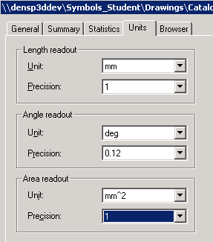
- Select File => Sheet Setup => Size and Scale tab. Set the file attributes to A1-wide/metric and select OK
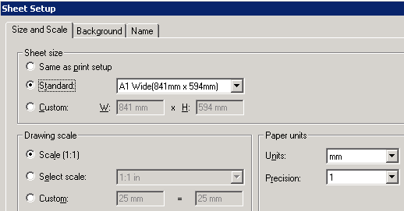
- Select Format=>Style…
- For Style Type: Dimension, select Modify and set units to metric, text size to 3.0 mm, and driven dimensions to color = Black
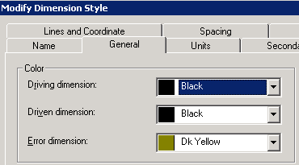
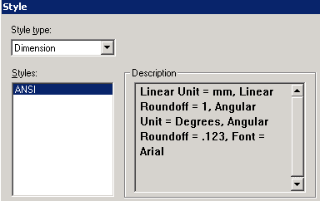
- For Style Type: Text, select Modify and set font to Arial, text size to 3.0 mm. This will control manually placed text
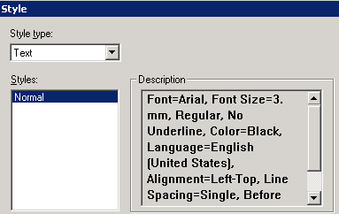
- Select Apply and Close
- Remove any default graphics from the file contents so that it is blank
- Maximize the viewing window and click Fit
- Save and exit

Creating the Border File from Old .dgn File

- Navigate to your plant’s metric templates folder at
\\yourSP3Dserver\ yourSymbolsShare\Drawings\Catalog\templates\Metric
- Copy an old A1 reference MicroStation border file to the templates\metric folder. For this example we have the file “Client_A1_Plotplan_Bdr.dgn”
- Copy the file A1_Wide.sha to your own border file name, i.e. Training_A1_Bdr.sha
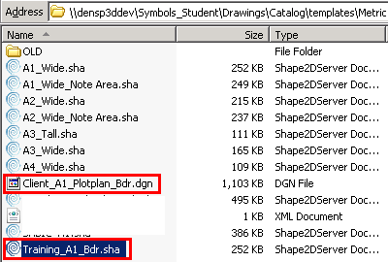
- Remove read-only properties and open Training_A1_Bdr.sha for edit
- Delete all existing graphics from this file
- Use File=>Sheet Setup to verify the sheet size and paper units are correct
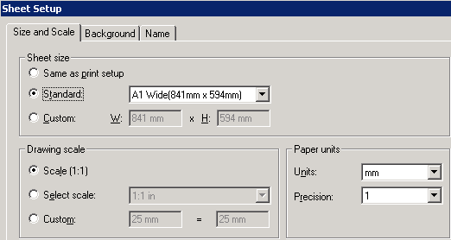
- Open the Client_A1_Plotplan_Bdr.dgn with the SmartSketch drawing editor
- Delete any graphics you do not want to transfer to the new border template
- Fence-inside all the border graphics and select Edit=>Copy
- Use Window menu option to switch back to Training_A1_Bdr.sha
- Use Edit=>Paste to paste the border graphics into your template
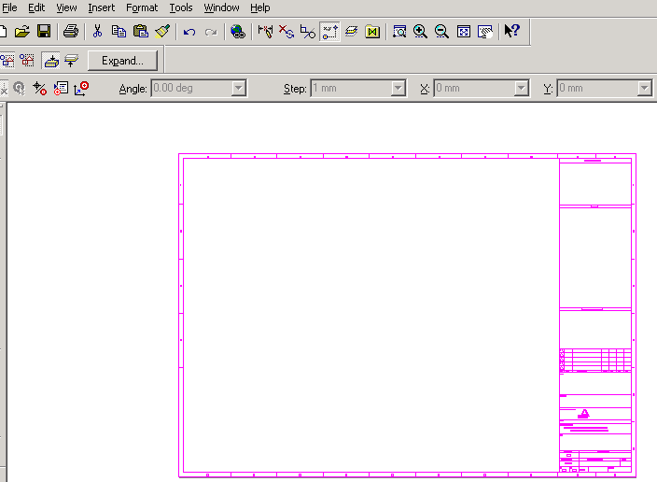
- Make sure the bottom left corner matches 0, 0 location. Pinpoint can be used, or simply make sure the paper-space gray outline matches the paper boundary (outermost frame) of the border just pasted
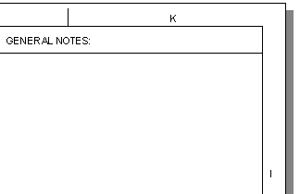
- Often, company logos don’t transfer 100% intact from MicroStation, for this exercise we will remove the “CAD” logo and insert a jpg image in its place.
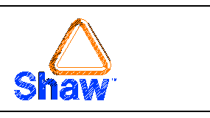
- Remove the existing company logo graphics and procure a jpg image of a Shaw or client logo with a white background. Save the logo image in the folder \\yourSP3Dserver\ yourSymbolsShare\Drawings\Catalog\templates\Metric
- In SmartSketch, select Insert=>Image…
- Navigate to the metric folder and select the image of the Shaw or client logo and OK
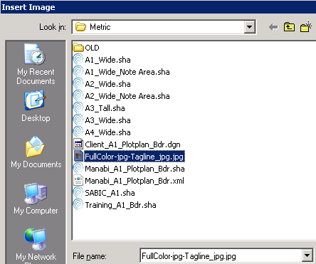
- Adjust the size of the image to fit in the designated area of the title block
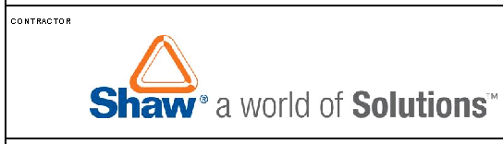
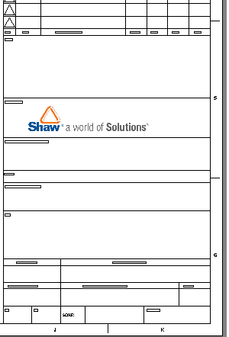
- Do take into consideration that if the end deliverables will be MicroStation or AutoCad files, it may be better to create a “CAD” (lines/shapes/fill) company logo here that will translate along with the drawing graphics later at delivery time
- Save and exit the border template
- Enter a session of SP3D and go into the training plant
- Switch tasks to Drawings and Reports
- Select Tools=>Edit Border Template…
- In the Select Template form navigate (double click) to the Metric folder and select the training border template, i.e. Training_A1_Bdr.sha and OK
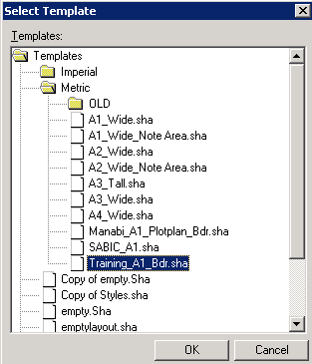
- Select the Place Drawing Area command and identify the graphics area of the drawing by selecting opposite corners:
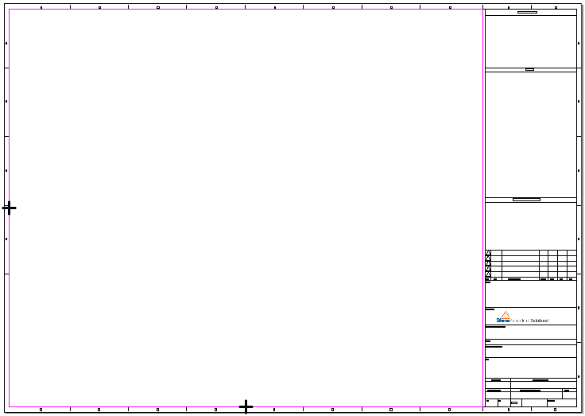
- Activate the Layers menu and set the active layer to DwgTemplate
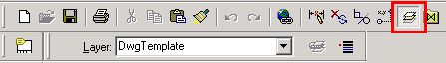
- Now fence-in all the border graphics so that they are all selected
- Select the Change Layer command 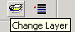
- Select DwgTemplate and OK. This will place all the graphics in the proper layer
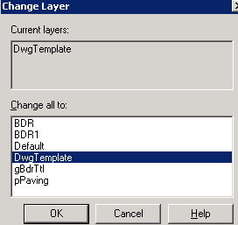
- Unselect graphics, select Format=>Text Box…
then set the Paragraph Font size to 3.0 mm. Make sure the text Border is turned off
- window-in to the title block area, and select the Place Drawing Property Label command
- From the first pull-down (Label set) select TitleArea
- From the second pull-down (Field) select DrawingNumber
- Click inside the drawing number box field. Nothing may seem to appear. To verify a text field has been added, click on the Select tool and move the cursor over the Drawing Number box in the title block. A box should highlight, click on it to select it
- Right click on the highlighted box and pick Properties
- Select Paragraph
- Change the Font size to 4mm and OK
- Stretch the box to better fit its field
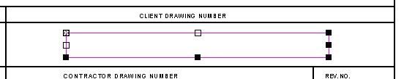
- OPTIONAL: for the curious minds, if you enlarge the drawing number field and double-click inside it, you will be able to see the XML language being executed to extract the value. With experience, you can edit the contents of this XML code to request a different value or parameters without having to place a whole new label
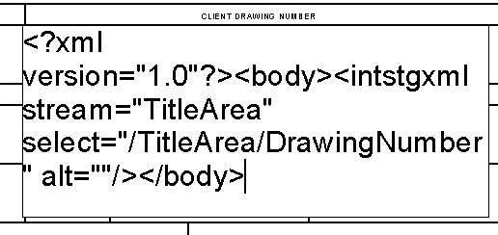
- Select the Place Drawing Property Label command to insert additional title block labels as needed using the procedure shown above.
Consider that placement defaults to Top-Left for the text boxes as you define their placement point
- Move your view to the revisions block
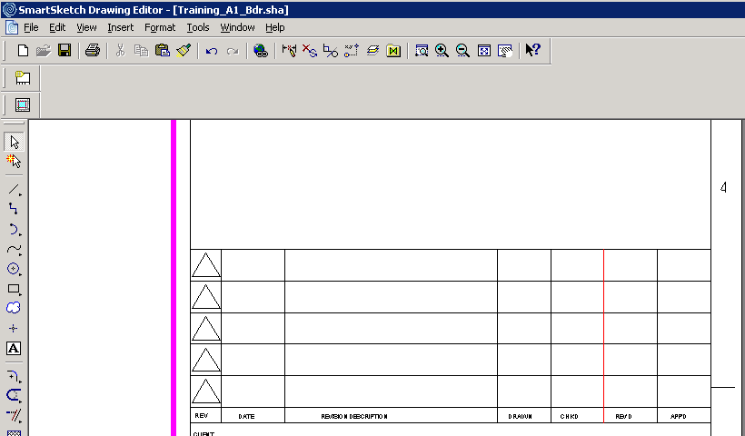
- Select the Place Drawing Property Label command to insert revision fields
- Set the revision fields as follows (the value in the box before 0 is a minus sign)
This field will contain the latest Rev number minus 0, resulting in the most recent revision number, therefore we will place the text box in the bottom left box:
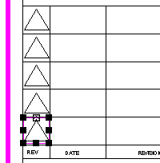
- Set the revision fields as follows:
This field will contain the latest Rev number minus 1, resulting in the revision number prior to the last, e.g. if last rev is at 3, then this box will display rev 2, therefore we will place the text box in the box right above the previous one:
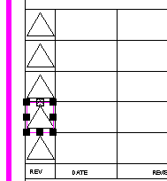
- Repeat for the remaining rev number boxes until the last one where rev number will be the latest minus four:
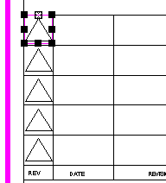
- Next, we repeat the process for revision dates. Starting with the date of the most recent revision on the bottom box, and working our way up:
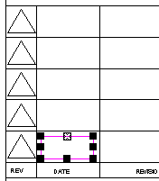
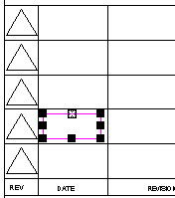
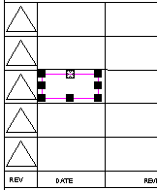
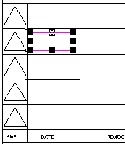
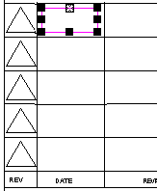
- Before continuing, fine tune the location of the rev labels. Multi-select the revision fields placed so far, right-click and select Properties
- Set the labels’ text to appear at center of text box, then center the text boxes inside their corresponding slots in the revisions block. It will take a few test runs to determine the optimal location for your labels
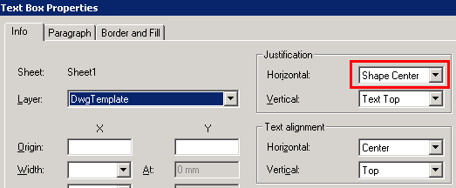
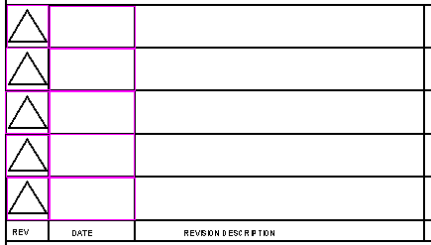
- ADVANCED: Place the label box for the Revision Description field, starting with rev 0. However, this time place only the label for rev description 0, then in Properties set its font size to 2mm, set alignment properties to left justified
- ADVANCED: Now, stretch the text box to fit inside the description slot
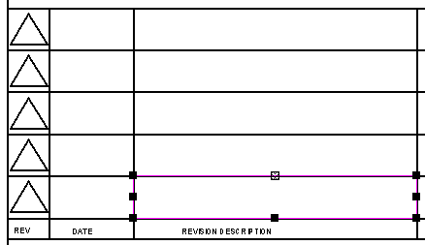
- ADVANCED: Copy this label box to clipboard, then paste a copy of it into every revision description slot
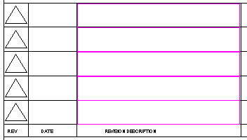
- ADVANCED: Now edit the XML code ONLY in the 4 text boxes just pasted and UP the subtraction value in each box, e.g.:
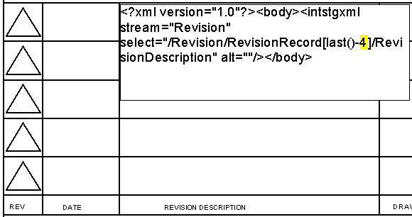
Hint: You will need to stretch the text box to twice its size, double click it, replace the 0 with the next number up (1/2/3/4), click outside the box to accept the edit, then resize the box to fit its revision description slot
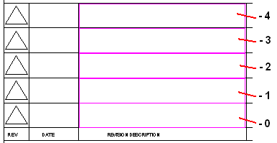
- OPTIONAL: Place the revision labels for Drawn/Chkd/Revd/Appd using either procedure shown above. In the interest of time you may want to move on and leave this for later.
- Fit the border file, save and exit

Defining the Styles Template

The file Styles.sha is used as reference to control automatic labels and dimensions symbology during drawing extraction.
- Navigate to \\yourSP3Dserver\ yourSymbolsShare\Drawings\Catalog\templates
- Make a backup copy of the existing Styles.sha file
- Open Styles.sha in the drawing editor. It is an empty file with some key presets used during automatic drawing creation
- Use File=>Properties and File=>Sheet-setup to make this a metric file if metric drawings will be generated
- Select Format=>Style…
- Notice the different style options:
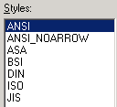
- By default, most Intergraph delivered labels are defaulted to use ANSI and ANSI_NOARROW styles. So that instead of re-pointing delivered drawing labels to use ISO style for metric output for example, what we do is customize the ANSI styles to use metric defaults. This way we customize once here, and then any delivered label we happen to use in our drawings will have the desired metric defaults
- With Style type set to Dimension, Select ANSI from the form and then click Modify…
- Under the General tab set the Driven dimension to Black
- Under Units tab set the units to mm, no unit label, and round-off = 1
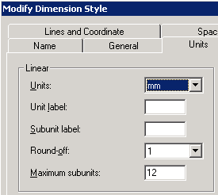
- Under Text tab set font to Arial 3.0mm (by default it is 3.1mm, so you must revise this even though it already may read “3 mm”)
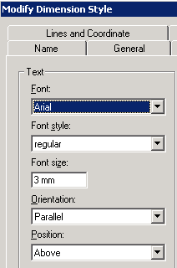
- Select OK, then Apply
- Repeat for ANSI_NOARROW but don’t hit Apply at the end
- Change Style Type to Text
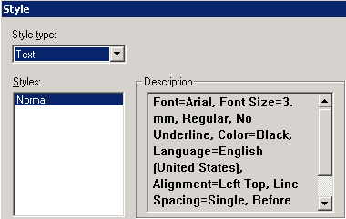
- Use Modify to set the default to 3.0mm Arial text
- Select Apply then Close
- Save and exit
PROPAGATING SETTINGS

In order for all template files to use only this Styles.sha file as a source, you will need to edit files empty.sha, and Training_A1_Bdr.sha (or any other border file you create) to point to this file for style resources. If not done, these files will look at the styles.sha on your C: drive and get their style parameters set to match the defaults in that file when your new orthos are created. In each template file you work on for a project, follow these steps:

- Determine the UNC path to your custom Styles.sha, i.e. \\yourSP3Dserver\ yourSymbolsShare\Drawings\Catalog\templates. For this example, we edited the styles file in \\housp3d01\SKEC_Sym_V9\Drawings\Catalog\templates. Therefore we will be pointing our templates to this styles file.
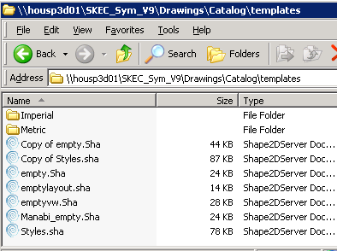
- Open each template file and select Format=>Style…
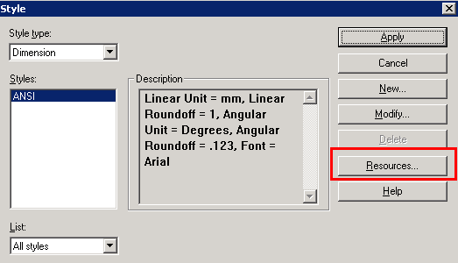
- Select Resources…
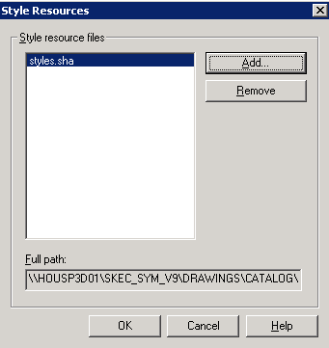
- If the Full path field shows a path to the C: drive, M: drive, or some other location unrelated to the current project, select “styles.sha” on the form and use Remove option to delete it. Then use Add…
- In the dialog box that appears enter the UNC path to where the good styles.sha is located, in my example: \\housp3d01\SKEC_Sym_V9\Drawings\Catalog\templates, then Open
- From the files that appear, select Styles.sha and Open
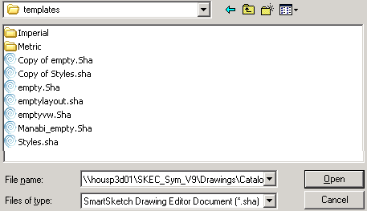
- Next select OK on the form, then save and exit
- Repeat for empty.sha and any new borders you may be working with

Testing and Fine-Tuning Templates

Now we will create a simple ortho drawing to test the new templates and their presets. Previous training in basic ortho drawing creation is assumed by these instructions.
- Open an SP3D session into the Intergraph training plant with a workspace showing All items in the plant
- Go to Tasks=>Space Management
- Place a drawing volume around units 02 and 03
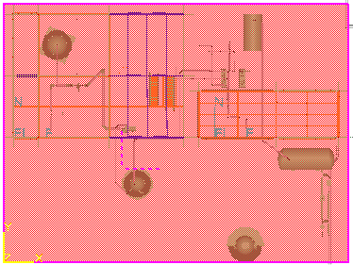 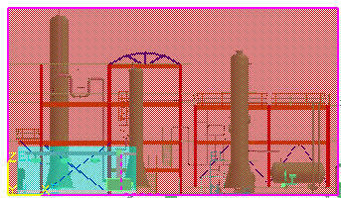
- Select Tools=>Drawing Console
- Under SP3DTrain>Drawings>Orthos define a new Composed Drawing component and rename it TemplateChecks
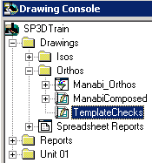
- Right click TemplateChecks and create a new drawing for our first test
- In the drawing properties sheet enter a drawing name, i.e. TemplateTest1, and select the empty.sha layout sheet (has no views pre-arranged, we didn’t spend time with this as we do not use this feature)
- Select the border template just created and OK
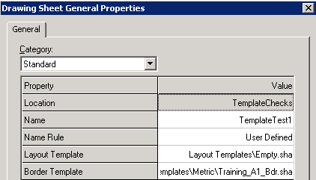
- The new drawing should appear using the new border
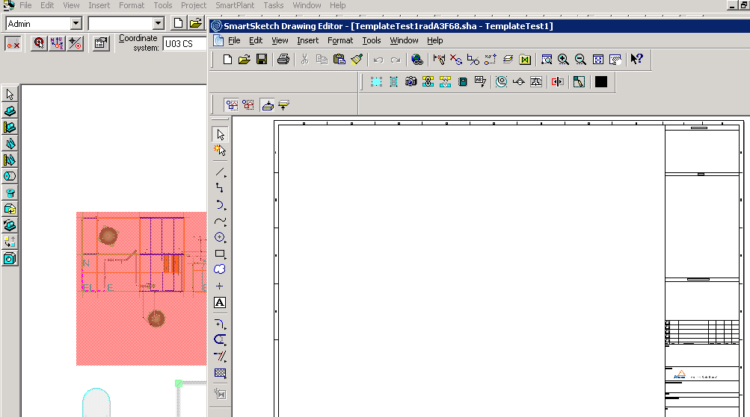
- Define a plan view in the new drawing. Use Equipment Plan_M as the style for the view.
Note: If you need a refresher on creating drawing views, see Shaw online training material for ortho drawing extraction
- Associate the new view to the drawing volume for units 02 and 03, then save and exit the drawing
Note: If you need a refresher on associating views, see Shaw online training material for ortho drawing extraction
- Use Tools>Drawing Console to see the new drawing. Right click the drawing name and select Properties
- Review/revise desired title block attributes.
Note: The training plant does not have a revisions tab under properties, possibly lost during translation from older versions of this plant. A live plant should have a revisions tab. If working in a live plant, and you mapped revision fields to the revisions block in the border file, define some rev information to make sure it maps well into the drawing during update.
- Update the new drawing and verify that border, units, symbology and annotations are consistent with your template presets. The next section of this document will explain the creation of a customized style rule
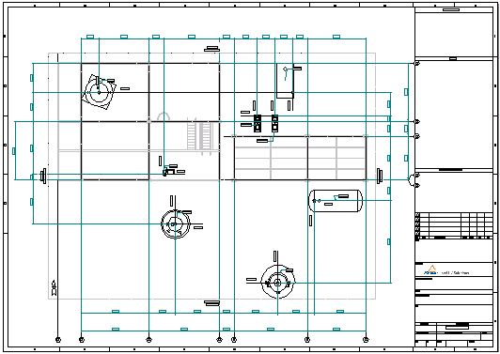

Defining a Customized Style Rule

The style rules are responsible for selecting the graphic items to be included in an ortho drawing view, then apply a graphic symbology to each item type, place automatic labels specific of the item types, and where needed place automatic dimensions. The style rule also defines the level of VHL detail at intersections, the north arrow to be added to the drawing, matchlines, and view description if desired.

Style Rule Interface
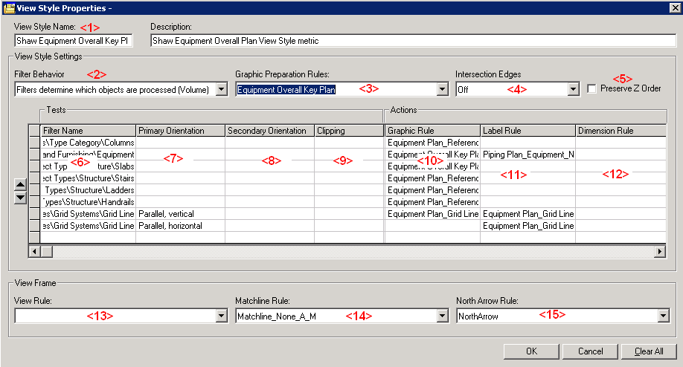

- View Style Name: Name of a style. When copying an old style for creating a new one, replace the old name with a new one. The system will ask if you are renaming the old style or creating a new one. Select YES to indicate that a new style is to be created
- Filter Behavior: Chose from either Volume or Snapshot. For this training we concentrate on volume
- Graphic Preparation Rules: This is a set of rules that will pre-process graphics items. For example, it can make equipment control points visible or invisible in an ortho view using the makedrwable.dll utility
- Intersection Edges: Points of intersection between graphic items, i.e. nozzle to equipment, can have a graphic placed at the point of intersection in low resolution, high resolution, or none at all
- Preserve Z order: Resulting 2D graphics on the ortho will be selectable in the order they originally appeared in the 3D environment
- Filter Name: Select a filter to test against. When items are returned by the filter (results are not-null), the subsequent columns of instructions are executed
- Primary Orientation: The items returned by the filter that match a primary orientation set here (Normal/Sloped/Parallel) are candidates for processing
- Secondary Orientation: The items returned by the filter that match a secondary orientation set here (Normal/Sloped/Parallel) continue to be candidates for further processing
- Clipping: The items returned by the filter that match a clipping setting selected here (clipped on the left, or right, or bottom, or top, anywhere, or not clipped at all) qualify for further processing by this rule. An item is considered clipped when any portion of its body is clipped by the drawing’ 3D volume
- Graphic Rule: This action rule dictates the line symbology to represent the graphic item on the drawing. The graphic item must meet the filter, orientation, and clipping criteria to get acted upon by this action
- Label Rule: This action rule dictates the type of automatic label that should be applied to the graphic item that has passed the test parameters. Multiple labels can be applied to a single item type. For example, equipment items can have a coordinate label and a separate name label placed automatically by creating two test records that return equipment items
- Dimension Rule: Items can be automatically dimensioned on the drawing, for example the distance from column to column in a piperack
- View Rule: Generates a view label indicating a drawing view orientation and scale
- Matchline Rule: On plan views, it activates the display of matchlines with corresponding coordinates, controlled by the N-S and E-W boundaries of the view’s 3D volume
- North Arrow Rule: Allows for the inclusion of a North arrow on plan views, either using a delivered arrow or a custom arrow symbol

Creating a New Style Rule

For this exercise, we will create a new style rule for equipment general arrangement views using delivered symbologies and labels. We will start from an existing style rule and then customize it to fit our requirements. The procedures below assume that the user has already received basic training on orthographic drawing creation
- Access SP3D and change tasks to Drawings and Reports
- Select Tools>Define View Style
- For the View Style Type select Orthographic
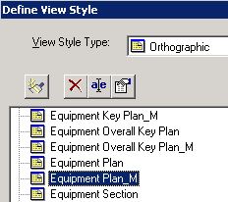
- Scroll down to select Equipment Plan_M (metric)
- Select the properties option
- Change the name to Shaw Equipment GA, enter a description, and OK
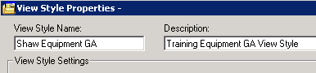
- You will see the following warning appear:
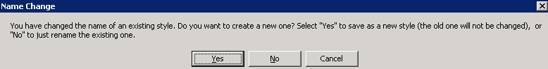
- Select YES to force the creation of a new style (This usually takes about a full minute to process)
- Select Tools>Define View Style...
- Select view style Shaw Equipment GA
- Select properties . This will show the current filter tests and actions to take. We will create a simpler but more useful style rule
- Currently this style will produce an ortho drawing like the one from the prior section in this document:
- We will eliminate the automatic dimensions first. In the Style Properties form, look under the Dimension Rule heading. Currently we get column-column, equipment-equipment, and equipment-column dimensions. This looks ok on views with few equipment items, but extremely cluttered in GA views of larger groups of equipment
- Delete the rows indicated in the screenshot below by individually clicking the buttons marked and pressing delete on the keyboard
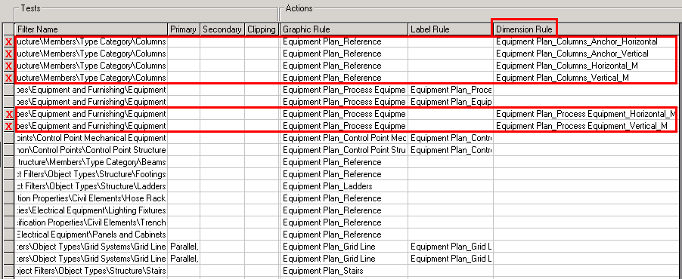
- Next, in a similar way delete the rows where the Filter Name does not capture equipment, columns, footings, beams, and grid lines
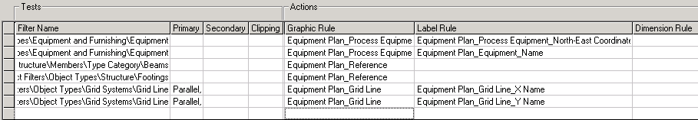
- Select OK on the form
- Right click the drawing created earlier (TemplateTest1) and select edit
- Inside the drawing, right click on the view frame and select Properties
- In the View tab, change the Style to Shaw Equipment GA and OK
- Right click the view frame and select Update View from the menu
- The drawing will take a minute or two to update
- Once update completes, the graphics will reflect the new settings. Review the drawing and exit
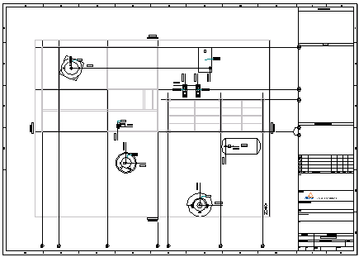

ADDING FILTERS AND SYMBOLOGY TO STYLE
Now we are going to use filters and graphics rules to locate structural columns footprints and make them stand out in the drawing
- In Drawings and Reports task select Tools>Define View Style
- Select Shaw Equipment GA and then properties
- Select the last (empty) box under Filter Name and pick More…
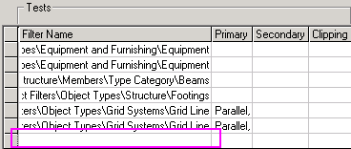
- Navigate the filters interface to Default Filters>SP3D Object Filters>Object Types>Structure>Members>Type Category>Columns
- In the Actions section, under Graphic Rules select the box at bottom corresponding to these columns, then pick More…
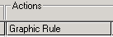
- In the graphic rule form select New…
- Name the rule: Shaw Visible Thick Solid. Enter a description
- Keep the aspect set to Simple Physical
- Set the properties as follows and OK the form:
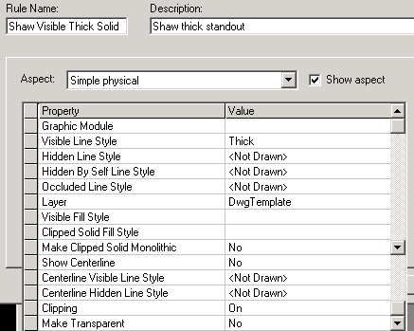
- Make sure the style properties look like this and OK the form
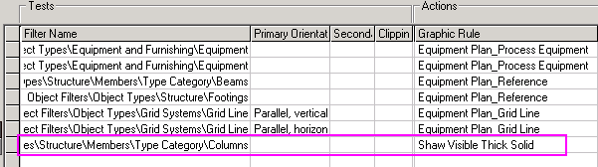
- Right click your test drawing (TemplateTest1) and select Update Now
- After the update, review the display of the columns, they should look as follows:
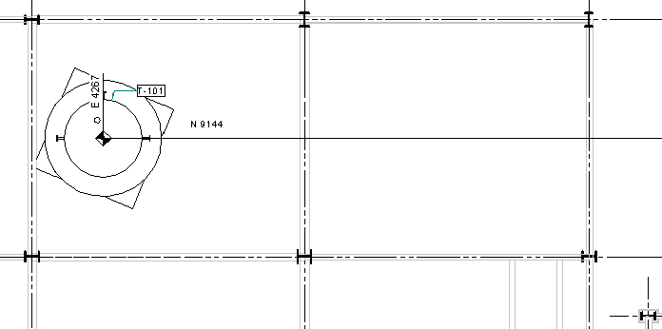

ADDING LABEL RULES TO STYLE
SP3D also allows the user to preset label generation for orthographic views in a drawing. The user defines a filter that locates “what” to label, then a label is selected that is predefined to label this type of item. This allows you to map any database attribute about an item onto the drawing automatically.
For the following exercise we will select an alternate name label for the equipment on a layout drawing. Notice the current label for equipment name:
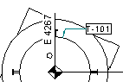
We will replace the equipment name label with a label without enclosure that places on the margin area.

- In Drawings and Reports task select Tools>Define View Styles…
- Select style Shaw Equipment GA and click Properties
- Instead of defining a new line, this time we will use an existing line where the filter is already defined for equipment. Look up the line where the filter points to Equipment and the label rule column has an equipment name label set. Change it to use name label Name_None_CPM_JL as shown:
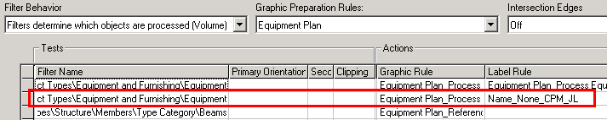
- OK to save and exit the style properties form
- Update test drawing TemplateTest1 and review the results
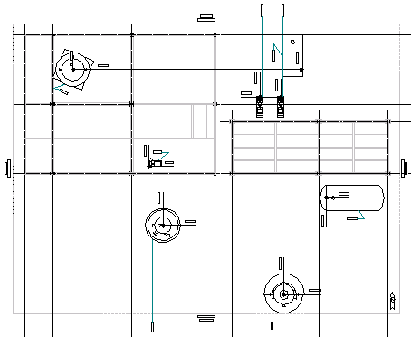
Note: A few labels did not get placed outside the matchline frame. A good part of the time managing Ortho styles is spent troubleshooting and getting labels to place and behave as best as possible so as to minimize manual arrangement. However, unlike Isogen drawings, Smartplant orthos will usually require manual post processing by the designer.
- Optional: Try using other delivered name labels for equipment to become acquainted with what is delivered

LABELING GRID LINES COORDINATES
- Return to Tools>Define View Style for Shaw Equipment GA and click Properties
- Notice that in the original style the distance between grid lines was automatically dimensioned. Since we removed the dimensions, we will provide Easting and Northing coordinates for each grid line
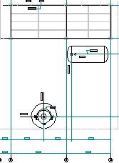 ➔ 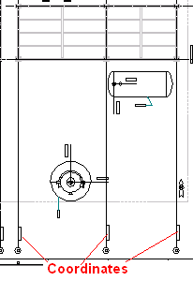
- In the Filter Name column, click a filter that ends in “…\Grid Systems\Grid Line”
- Right click this line once it’s highlighted. Select copy from the right click menu (else you can use More and pick the filter from the filters interface)
- Click on the bottom empty line in the Filter Name column and paste the grid line filter path name
- Under Primary Orientation select Parallel,Vertical
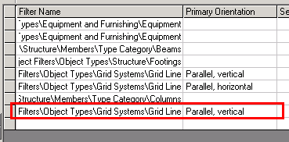
This tells the system to locate all grid lines, but then only process those that are vertical
- For the Graphic Rule leave a blank. The line style for grid lines was already set a couple of rows above
- For the Label Rule use GridVertCoordinateLabel
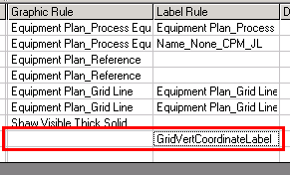
- Repeat the previous steps to setup coordinates for the horizontal grid lines, using GridHorizCoordinateLabel to place the North coordinates. The style properties should look as follows:
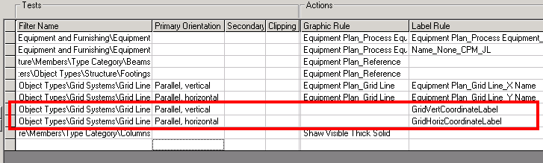
- Select OK to save and exit
- Update test drawing TemplateTest1 and review the results (coordinates in red below)
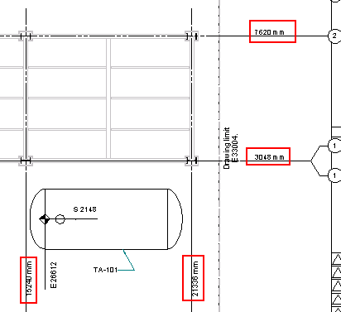
Note that the grid coordinate values are measured from Global Origin, such that coordinates for equipment and grid lines disagree, since equipment items’ coordinates are from the specified Unit03 coordinate system. CAE has reported this to Intergraph.
Also notice that the coordinates for Easting fall inside the drawing limit frame. Users need to use the SmartSketch Move command to fine tune the location of coordinates to the outside of the match line frame.

MODIFYING LABEL FORMATS
Notice the format of the coordinate labels in the previous exercise. The project would like for them to be unit-less (mm implied). To achieve this we will need to edit the label format. Customizing labels is similar to reports extraction and could be the topic of a training course by itself. This document will only cover some basic aspects.
- Install Cooktop on your SP3D machine (or any other text editor able to handle XML tagging). Contact CAE Houston for location of Cooktop software
- Navigate to your training plant’s symbols share. Find folder \\yourSP3Dserver\ yourSymbolsShare\Drawings\Catalog\Labels\Templates
- Find GridHorizCoordinateLabel label definition
Notice that a label definition consists of up to 6 different files working together to extract a datum from the database and then format it for placement in a drawing
- Select all the files for GridHorizCoordinateLabel (xml, sym, rtp, rqe, rfm)
- Hold down the control key and add to the group the file GridCoordinateLabel.rfp
This file is shared by the horizontal and vertical grid line coordinate labels to format the output
- Right click and go to properties to remove Read-only attribute
- Right click and save the group of files into a zip or rar backup archive, i.e. GridHorizCoordinateLabel.zip. Should you edit one of these files beyond repair, you can restore it from this archive. Also, later in the process you will save the new labels to a company specific name and restore these originals (very important step to avoid losing your work next time there’s a plant version upgrade).
- Find the group of files for GridVertCoordinateLabel in windows explorer, also multi-select all of them to remove read-only status and save them to a zip or rar file
- Open GridCoordinateLabel.rfp in Cooktop. Ok to associate .rfp extension with Cooktop
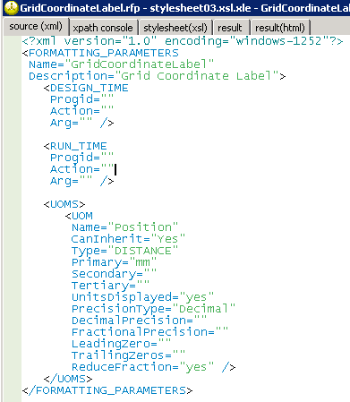
- Set UnitsDisplayed to “no”
- Run update of test drawing TemplateTest1
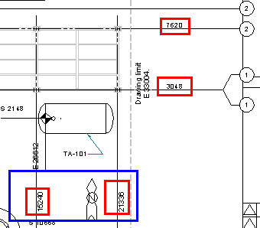
Notice the mm marks are gone now. You will likely want to add E or N to the tag next, a glitch to the delivered format prevents this. CAE has informed Intergraph of this, and we have a customized set of format files that works around this that we’ll use for production work instead of these training files.
- Notice the Easting coordinates in the blue box above. The project may need these coordinates above the grid line. To adjust the location we will edit the xml file driving these labels’ location
- Open the file GridVertCoordinateLabel.xml in Cooktop. Ok to associate .xml extension with Cooktop
- Search the following tag: <hoffset>
- Set the tags connectPoint, horizontal and vertical offsets values as follows:
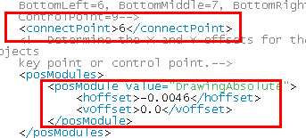
These are decimals of a meter, so that sometimes it is necessary to try a number of values before arriving at an ideal offset
- Save the edits to this xml file
- Run update of test drawing TemplateTest1
- Look for the vertical coordinates (Easting) on the drawing and review their location
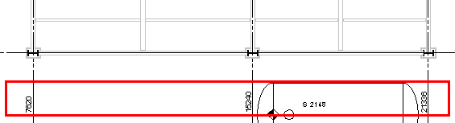
The specified offsets in the xml file are measured with respect to the actual grid line (dashed). That’s why they will appear not so far from the structure even if it’s well inside the view match lines.
- To place these coordinates outside the match line, the designer will need to multi-select these coordinates, select the move command, lock the X axis and drag them down along Y. There is an open request at Intergraph for a grid bubble label that automatically produces the coordinate label next to the bubble to produce the look we want automatically:
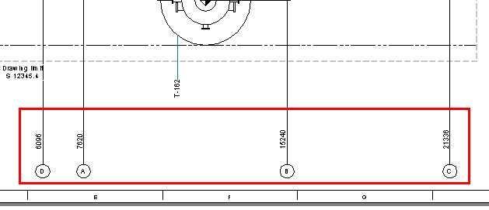
- Next, we will make these coordinates 3mm and stand out by setting their font to bold
- Navigate to your training plant’s symbols share. Go to folder \\yourSP3Dserver\ yourSymbolsShare\Drawings\Catalog\Labels\Templates
- Locate file GridVertCoordinateLabel.sym in this folder and remove the read-only setting if not done earlier
- Double click to open file GridVertCoordinateLabel.sym in SmartSketch
- This file was originally configured by Intergraph for English units. We will make it into a metric file first
- Select File>Properties and in the Units tab make mm the default readout with one decimal and OK
- Select File>Sheet Setup and set the paper units to mm with one decimal
- Now in graphics click on the text “GridVertCoordinateLabel”
- Notice the text size is actually 3.2mm
- In the text size box enter 3.0 and Enter
- Select the Bold button for this text
- Save and exit this file
- Repeat this procedure for the Northing coordinates in file GridHorizCoordinateLabel.sym
- Run update of test drawing TemplateTest1
- Review the grid coordinate labels. Click on them to verify text size in the ribbon menu
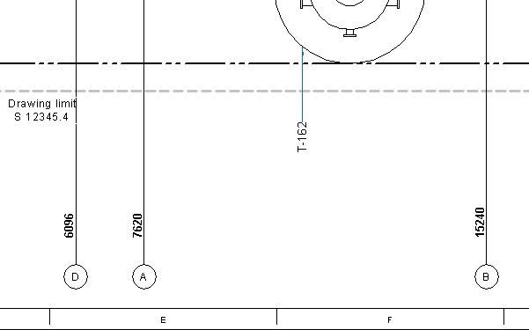
IMPORTANT: When you create new labels of any type using Intergraph labels as a starting point, you will need to perform this procedure to make the text sizes true metric
NORTH ARROW
Different projects may require their own version of the North arrow. This exercise will guide you through the process of defining a new North arrow for automatic placement in all plan orthographic drawings.
- Go to your training plant’s symbols share. Go to folder \\yourSP3Dserver\ yourSymbolsShare\Drawings\Catalog\Labels\Templates\NorthArrows
- Copy the files NorthArrow.sym and NorthArrow.xml to
TrainNorthArrow.sym and TrainNorthArrow.xml
- Revise these files properties and remove the read-only setting
- Open TrainNorthArrow.sym in SmartSketch
- Change File>Properties to mm units
- Replace the current North arrow with one of your own design, make it 50mm tall, i.e.:
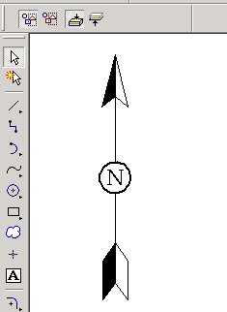
- Save and exit
- Now we need to make this new North arrow available for selection into our style.
Navigate to folder:
\\yourSP3Dserver\yourSymbolsShare\Drawings\Catalog\Rules\NorthArrowRules
- Copy the file NorthArrow.xml (it’s not the same one you worked on earlier) to TrainNorthArrow.xml
- Edit TrainNorthArrow.xml and make the adjustment shown, then save and exit
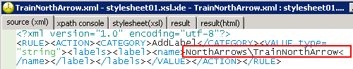
- In SP3D go to Drawings and Reports task, then open Tools>Define View Style…
- Select Shaw Equipment GA for Edit
- Set the North Arrow Rule to TrainNorthArrow and OK
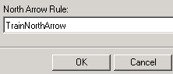
- Run update of test drawing TemplateTest1 and review the resulting North arrow. Measure it to ensure the correct dimension of 50mm
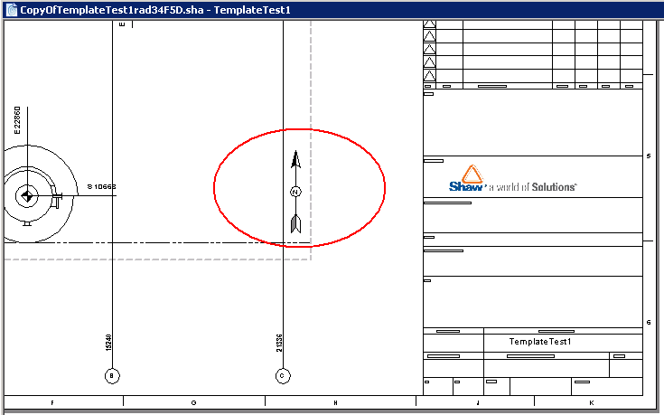
- To move the default location of the North arrow, go to folder
\\yourSP3Dserver\yourSymbolsShare\Drawings\Catalog\Labels\Templates\NorthArrows
- Edit file TrainNorthArrow.xml and test new values of the following location parameters:
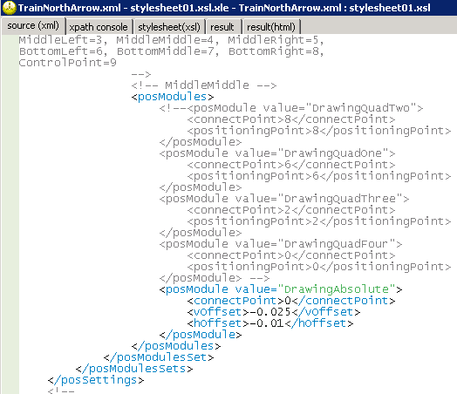
Notice that the quadrant values have been commented out to force the North arrow to one consistent location per the vertical and horizontal offsets, resulting in this location:
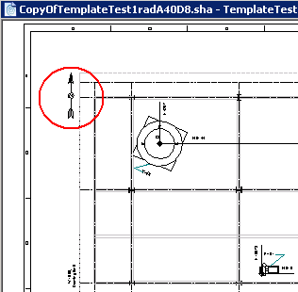
MAKING NEW NAME AND COORDIINATE LABELS SHAW SPECIFIC
Until now we have been modifying delivered labels. If we were to upgrade the training plant to the next version of SP3D, the process of upgrading the symbols share would overwrite our customizations with the std delivered files. Just like we did with the North arrow files, we will now make our labels Shaw specific labels and then restore back any delivered files changed to their original condition.

Name Label
Generate a Shaw-specific name label that looks as follows (highlighted in red):
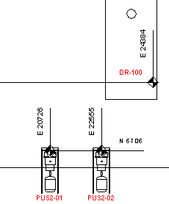
- Go to \\yourSP3Dserver\yourSymbolsShare\Drawings\Catalog\Labels\Templates and locate the equipment label Equipment Plan_Equipment_Name
- Select the following files defining this label: .sym, .xml
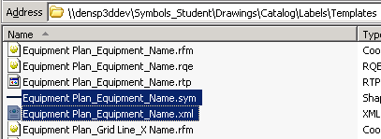
- Copy/Paste the selected files and rename them to have a Shaw prefix
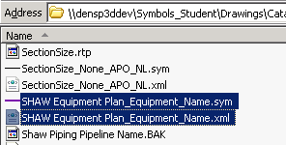
- Open these files properties and remove the read-only status
- Double click Shaw Equipment Plan_Equipment_Name.sym to open it in SmartSketch
- In the SmartSketch editor use File>Properties and File>Sheet Setup to make this a metric unit file using mm with 1 decimal
- Right click the text “Equipment Plan_Equipment_Name” and select properties
- Verify that justification and alignment are set to Center
- In the Paragraph tab set the font size to 3.0mm, bold, and the color to Red (the color change is for ease of verification in this exercise, not likely something you will do for a project production label)
- In the Border tab unselect the Show Border check box
- In the User tab review the Value field, this is the attribute that is being automatically mapped to this text box.
TIP: The user can “freeze” a label, or cause it to no longer be automatically controlled by Smartplant’s drawing update, by removing this value and leaving a blank instead for a label that has already been placed in a drawing. Do not alter it for this exercise.
- OK the text properties form, save and exit the sym file
- Open the file Shaw Equipment Plan_Equipment_Name.xml in Cooktop
- Search the tag <name> near the top
- Set the name attribute to: <name>Shaw Equipment Plan_Equipment_Name</name>
- We will place the label on top of the equipment, so set Granularity to 0, since we are not looking for clear space: <granularity>2</granularity>
- Search for tag <posModules>
- Comment out the quadrant preferences that select an area around equipment to place the label. We don’t need this since we are placing the label on top of the equipment.
Hint: Highlight each line and press function key F11, one at a time to keep it simple
- Set the horizontal offset below to 0.0 and the vertical offset at -0.01. This will place these equipment tags just below the center of the equipment:
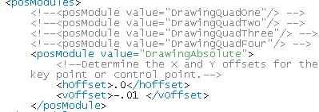
- Remove the leader settings content since we do not need a leader line with this label
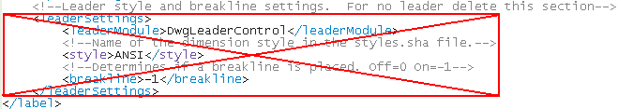
- Save and exit this xml file
- Go to \\yourSP3Dserver\yourSymbolsShare\Drawings\Catalog\Rules\LabelRules
- Locate file Equipment Plan_Equipment_Name.xml
- Copy/Paste this file, remove read-only attribute and rename to
Shaw Equipment Plan_Equipment_Name.xml
- Open this new file in Cooktop and perform the following edits:
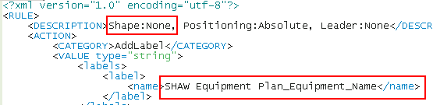
This is how this label will be presented in the labels interface for selection
- Save and exit this xml file
- Go to Tools>Define View Style
- Select Shaw Equipment GA for edit
- Set the label rule to use the new Shaw label:
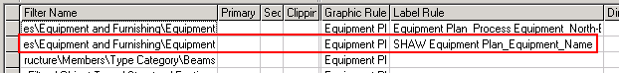
- OK the form to save and exit
- Right click your test drawing TemplateTest1 and select Update Now
- Review the drawing contents:
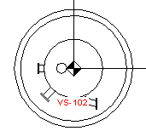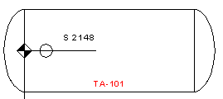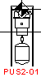
- Notice that we only had to copy and edit two files, the .sym and .xml. This is the case when you are using the same attribute, i.e. eqp name, but only need to change its appearance. In situations where you are building a full query for a different attribute, i.e. eqp description, then you will need all 5 files associated with a label (advanced topic for future training).
Coordinate label
Rename the grid coordinate label created earlier to a Shaw-specific name.
- Go to \\yourSP3Dserver\yourSymbolsShare\Drawings\Catalog\Labels\Templates and locate the .xml and .sym files for GridHorizCoordinateLabel and GridVertCoordinateLabel
- Copy these files to new files with the Shaw prefix:
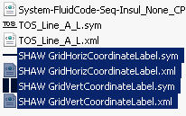
- Edit Shaw GridHorizCoordinateLabel.xml to set the name to have the Shaw prefix:
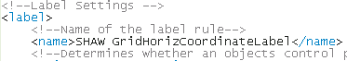
FYI: the following pointer further down in this xml file is what takes advantage of the delivered label’s query and settings:
- Save and exit this file
- Repeat this procedure for Shaw GridVertCoordinateLabel.xml
- Go to \\yourSP3Dserver\yourSymbolsShare\Drawings\Catalog\Rules\LabelRules
- Locate file GridHorizCoordinateLabel.xml
- Copy/Paste this file, remove read-only status, and rename it to
Shaw GridHorizCoordinateLabel.xml
- Edit this xml file contents as follows:
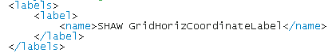
- Save and exit this xml file
- Repeat this procedure to create a file named Shaw GridVertCoordinateLabel.xml
- Go to Tools>Define View Style and set the grid lines coordinate labels defined earlier to use the new Shaw-specific grid line coordinate labels
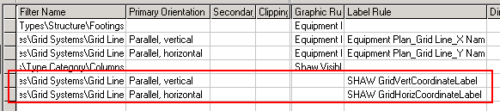
- Right click your test drawing TemplateTest1 and select Update Now
Note: To make sure the new labels are being used, you may want to edit the .sym files and change the font colors. After update completes, make sure the font colors selected were used, that is indication that the system correctly used the Shaw labels and not the Intergraph delivered ones we had been using until now. Change the font color back to black after review.
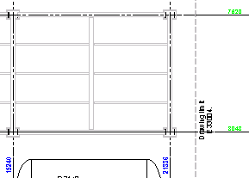
- Open the archive created earlier with the delivered grid coordinate labels, i.e.
GridHorizCoordinateLabel.zip / GridVertCoordinateLabel.zip
- Restore the delivered files back into \\yourSP3Dserver\yourSymbolsShare\Drawings\Catalog\Labels\Templates

LABS

Lab1-Structural
- Create a Shaw style rule for structural framing plans.
- Customize it to show only frame members and footings.
- Experiment with single line, line and widget, and double line for beams and braces
- Create a Shaw style rule for structural framing elevation.
- Customize it to show only frame members and footings.

Lab2-Piping
- Create a Shaw style rule for piping plan
- Make piping less than 4in NPD appear as single line
- Make piping 4in NPD and greater thick, black
- Make equipment and structural disciplines appear light gray
- Make sure electrical discipline graphics are not included in the output
- Activate the use of Intersection Edges for better detail
- Make sure that clipped piping gets labeled at clipped point
- Make sure that only the longest piping run is labeled for a pipeline
- For pipes coming out of the drawing, ensure that there is a symbol to indicate this end, i.e. 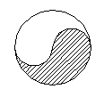
- No automatic dimensions
- Create a Shaw style rule for piping isometric detail using the parameters from the above instructions, BUT no labels.
Hint: For all of the above, explore multiple Intergraph delivered styles before getting started. Solutions to all of the above requirements are found in some of these styles.

